Local tender template-only with Auction
Create Auction from Demand Specification

In this article the process will be described in case an Auction (without RFP) will be created from Demand Specification.

The main steps are:
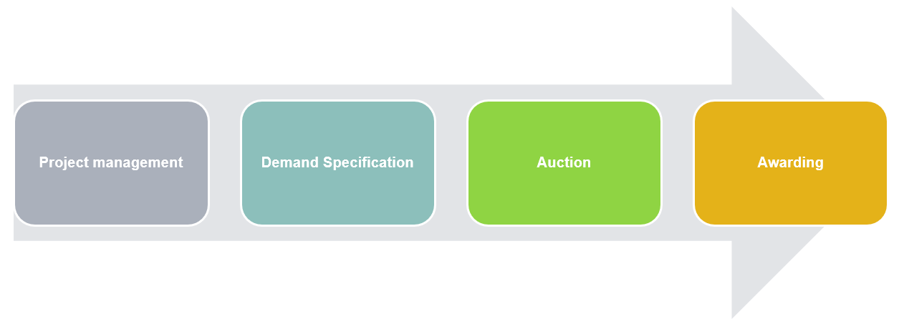
Note: It is mandatory to create the projects from the RFX module and to define and maintain articles under Demand Specification.

Steps in eSourcing to create only an Auction from Demand Specification:

From the Main Menu, go to Project Management / RFX and then Project List.

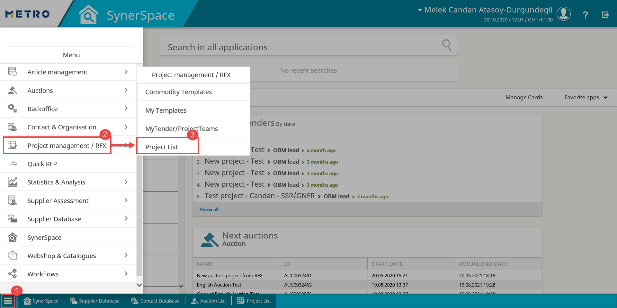

Click on NEW to create a project and select Local Tender Template (when needed you can conduct a search in order to find the correct template) and click on APPLY to proceed with the project creation.
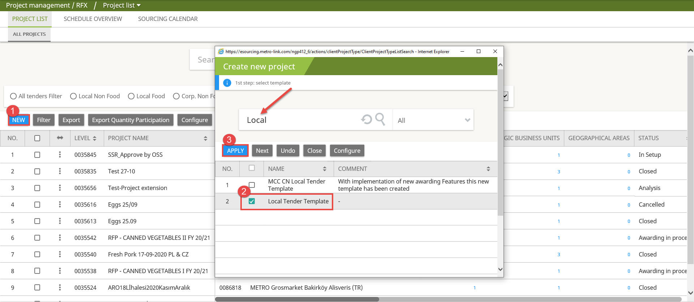

- Project Management:

  - Check and complete mandatory fields in the Project Details tab.

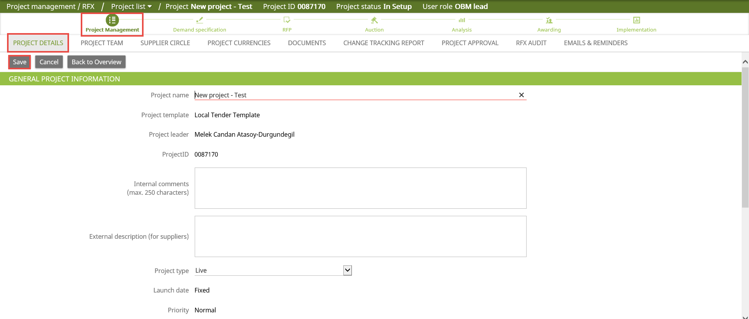
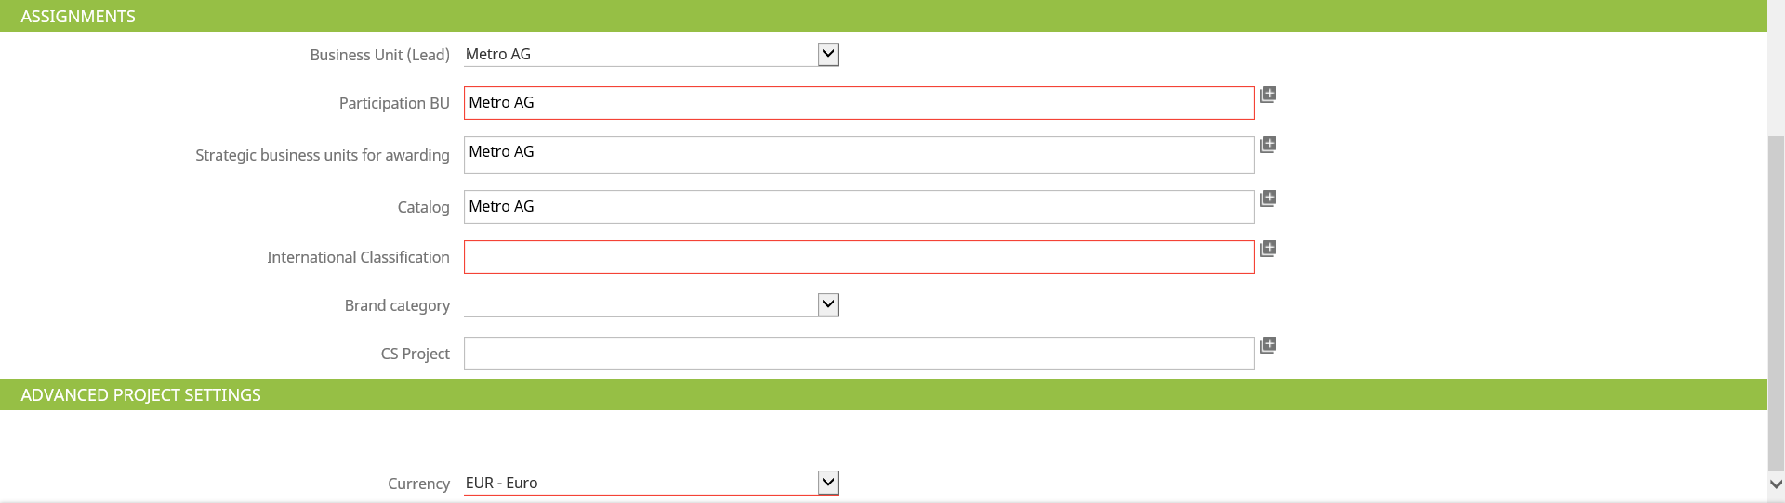

- Project title – update or provide a name for the Project, if needed
- Version – Live
- Internal Comments /External Description – if needed
- International Classification - COMS for your articles
- And all the relevant information of your project.

Note: Red highlighted fields are mandatory to be filled.

Click on Save to continue.

  - In Project Team you can invite your colleagues into your project. Click on ADD to invite.

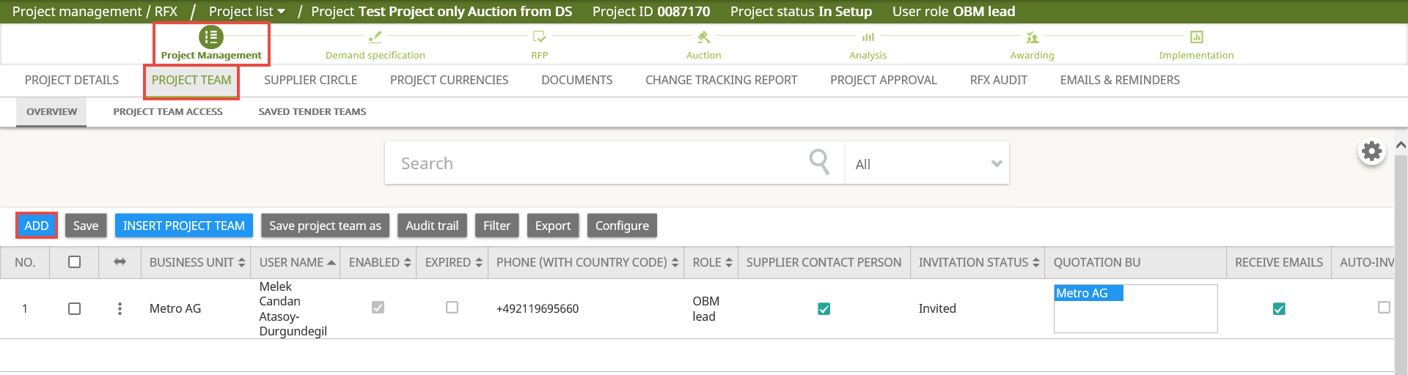

Find the correct internal user, select the tick box and click on Add to Project team.
Select the related role for this user from the upcoming pop-up screen and click on Apply to proceed.

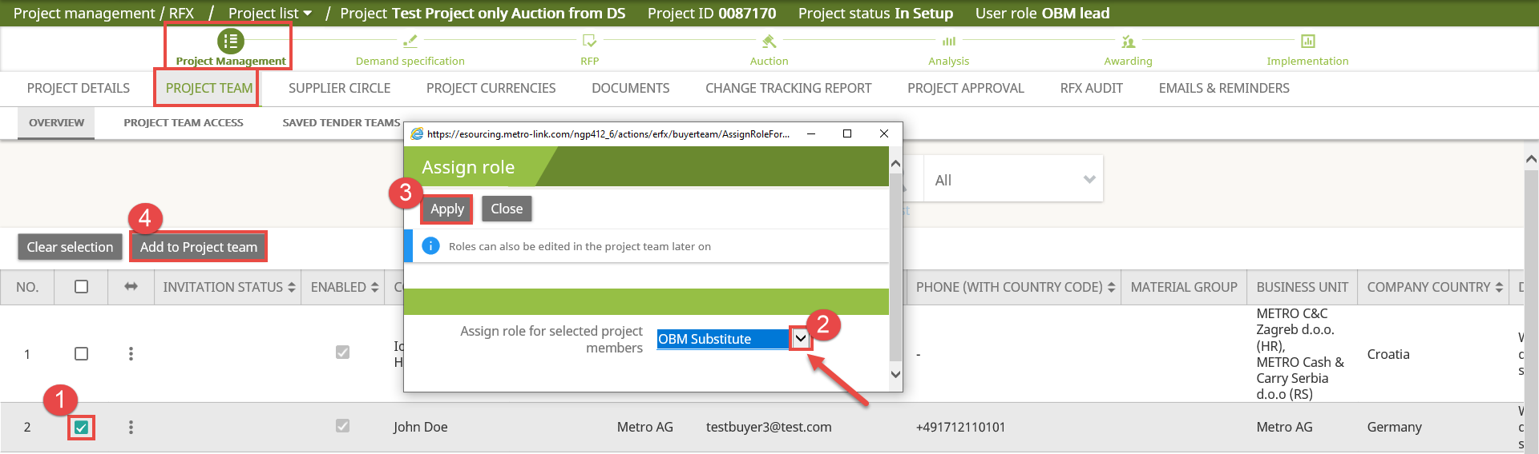

To go back to your Project Team list, click on BACK TO PROJECT TEAM.

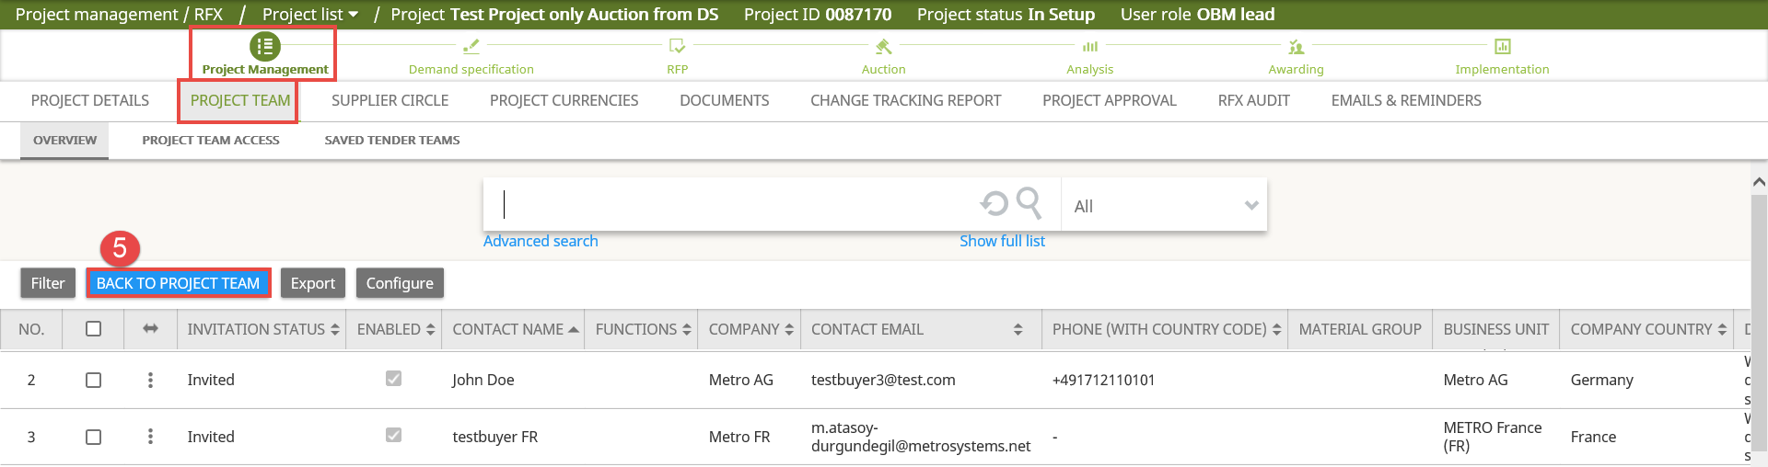

Note: You can save your project team (from “Save project team as” icon) and reuse this project team (from “Insert project team” icon) in your upcoming projects.
  - In Supplier circle you can invite the suppliers to your project. Click ADD to invite suppliers.

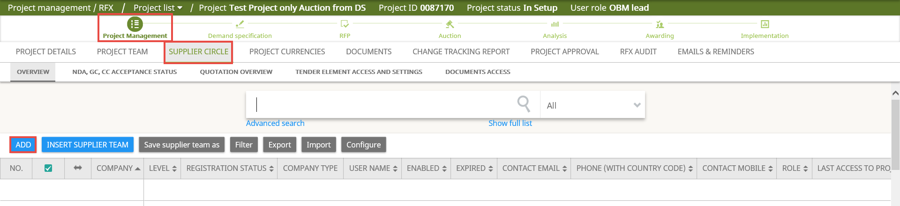

For the suppliers which are already in the eSourcing System, please follow the steps below:

Search and find your suppliers, select the tick box, then click on Add to current project.

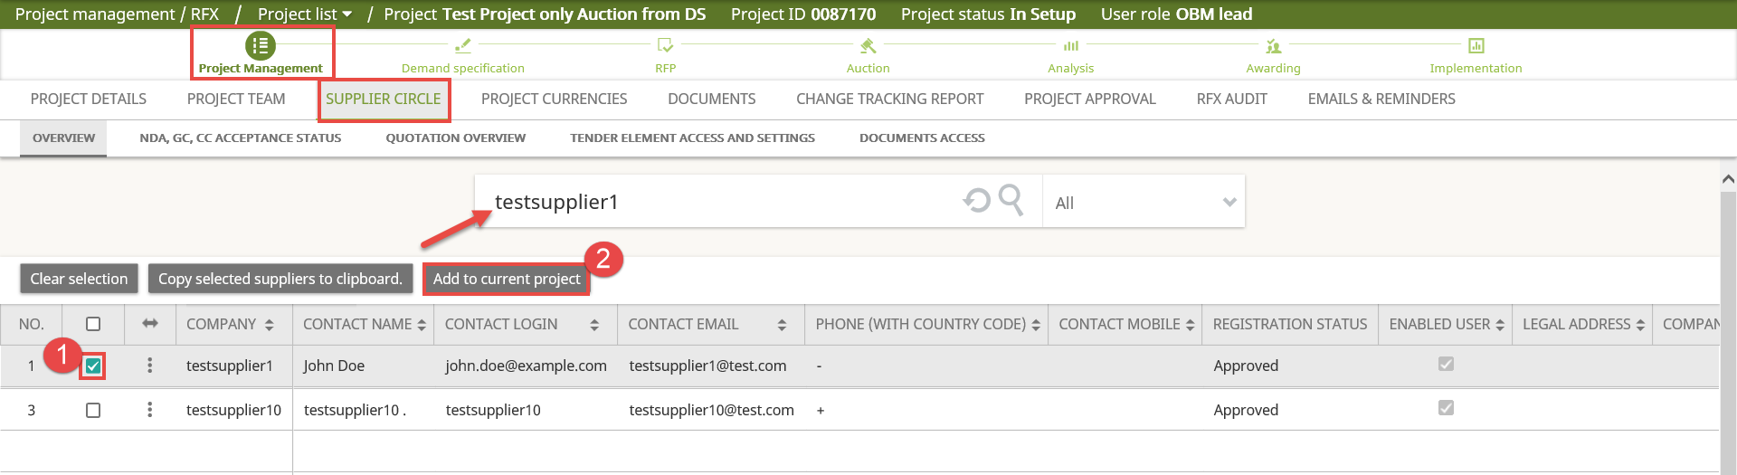

Repeat this step as many suppliers as you would like to invite. To go back to the Supplier Circle list, click on Back to Supplier Circle.

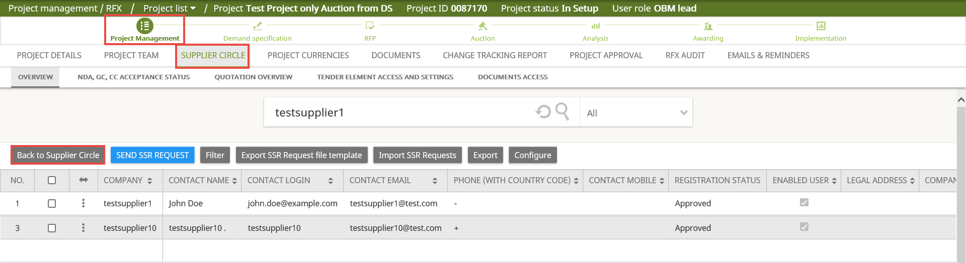

If suppliers are not yet in eSourcing System, proceed with SSR process.

Please click here to find out how to Send Request to Supplier via RFX.

Note: You can save your Supplier Team (from “Save supplier team as” icon) and reuse this supplier team (from “Insert supplier team” icon) in your upcoming projects.

Note: From the compliance regulations, at least three suppliers should be invited to the eSourcing projects.
  - In the Documents tab, you can upload all relevant documents for your project. Click on either Upload or MASS UPLOAD.

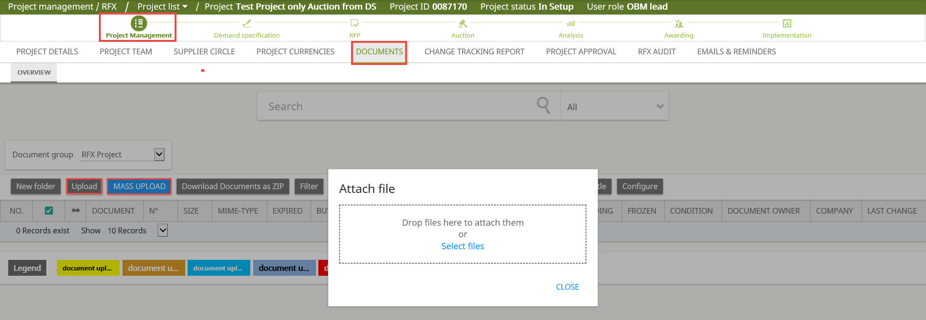

By default, the documents are given buyer/buyer participant access.

At least one document must be set as GC (General Conditions).

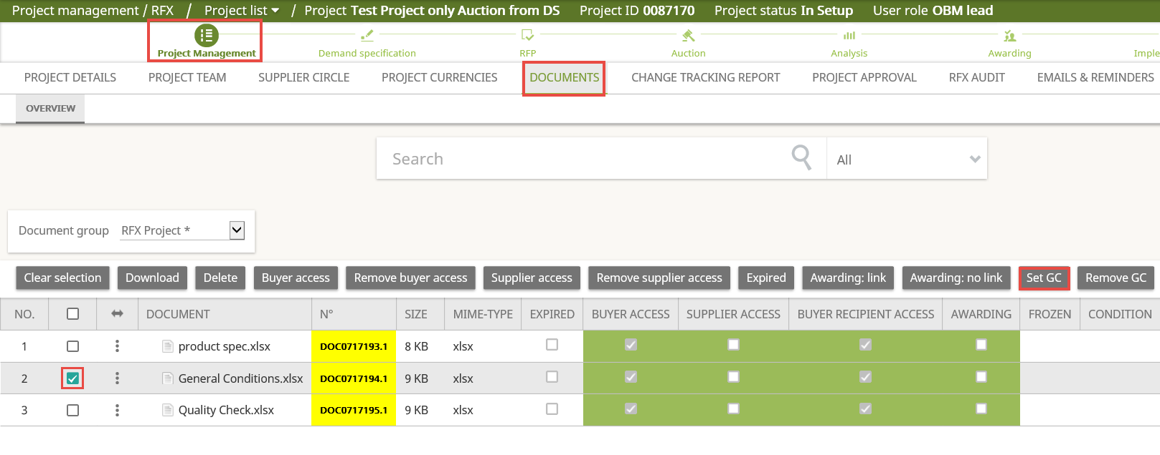

Supplier access should be provided for the documents which need to be shared with the suppliers.
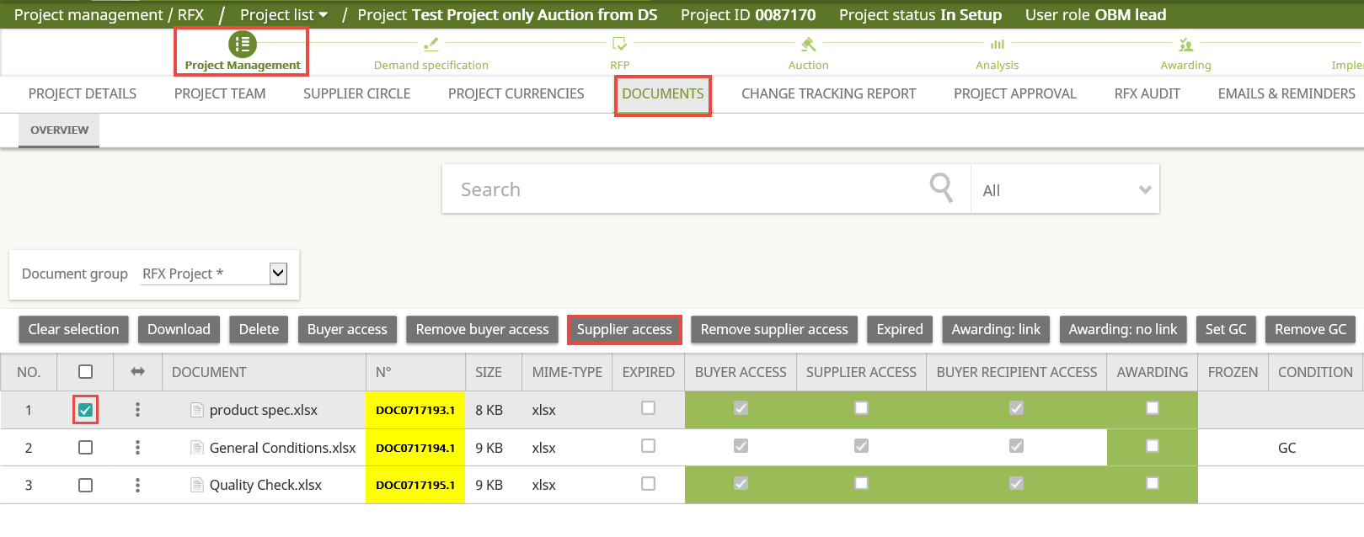

- Demand Specification:

In Demand Specification tab, you can define the articles for your project. There are two options available:

  - Negotiate existing articles

- Click on Insert existing article
- Search for your articles which are in “Active” Status
- Select your articles
- Click on Renegotiate Article

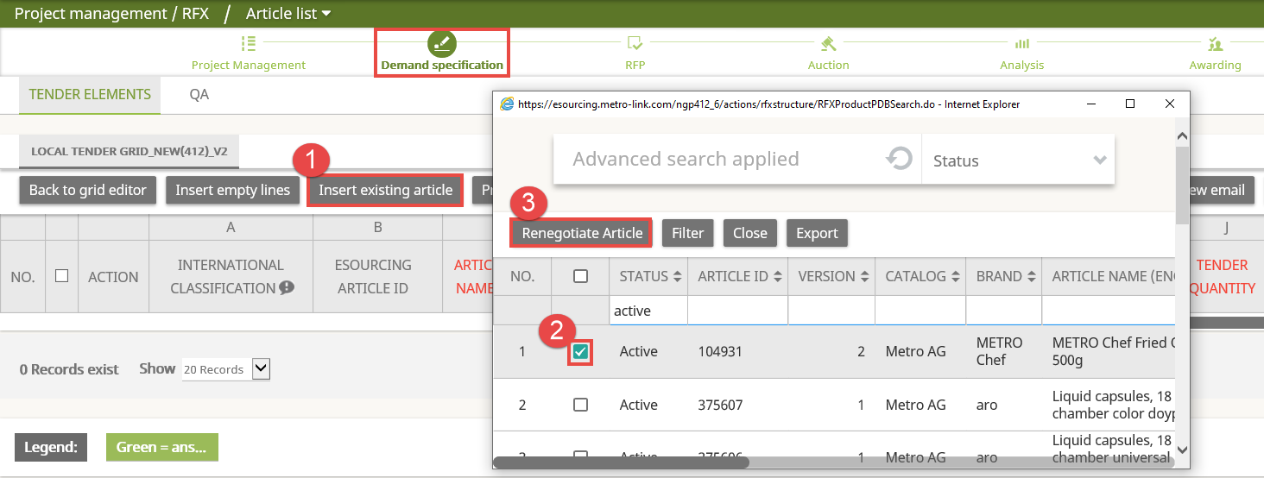

Note: You can always add new articles and adjust information on existing articles.
  - Create new articles

- Click on Insert empty lines
- Enter the number of articles you would like to create and click on Apply

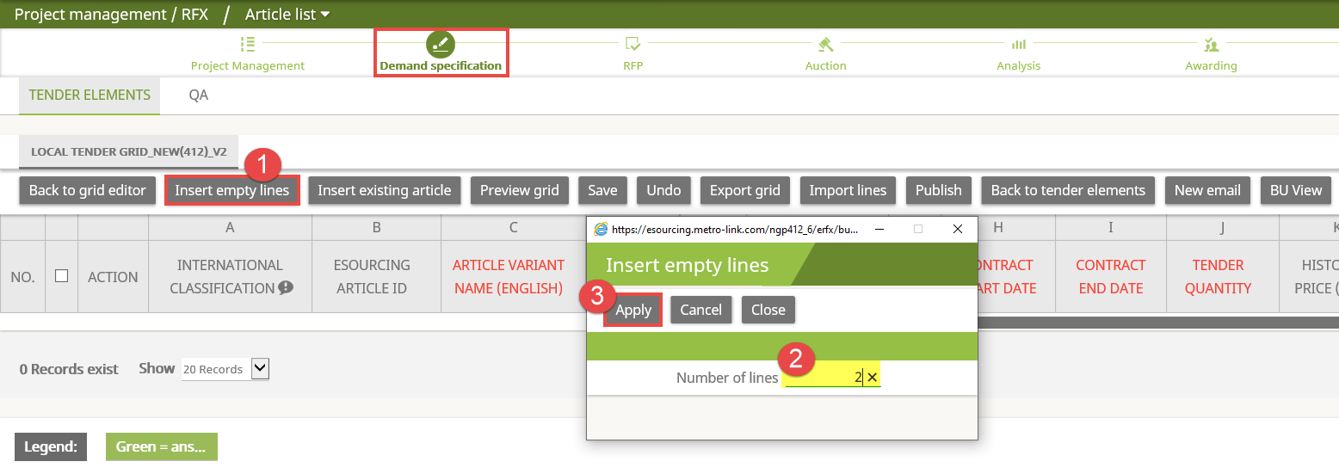

- Fill in your article information (column A to column K), mandatory fields are:
  - Article Variant Name (English)
  - Contract Start and End Date
  - Tender Quantity
- Click on Apply
- Click on Close internal phase in order to publish and close Demand Specification

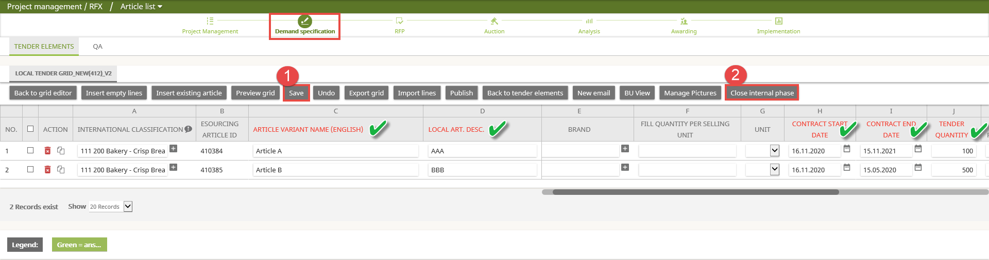

- Auction:

Click on NEW to start with the Auction set up.

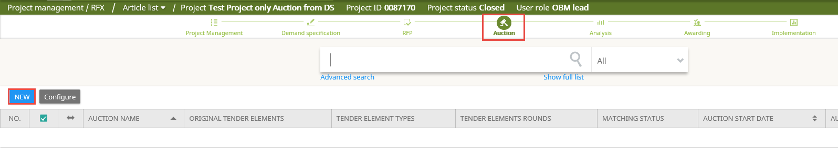

There are four steps for setting up the Auction from Demand Specification:

  - General Data

- You can keep or update the name of your Auction.
- You can add/remove Project Team members.
- You can remove Suppliers.
- If you want to transfer all the documents from RFX to the Auction, select the tick-box.
- Click on Save to continue with the second step.

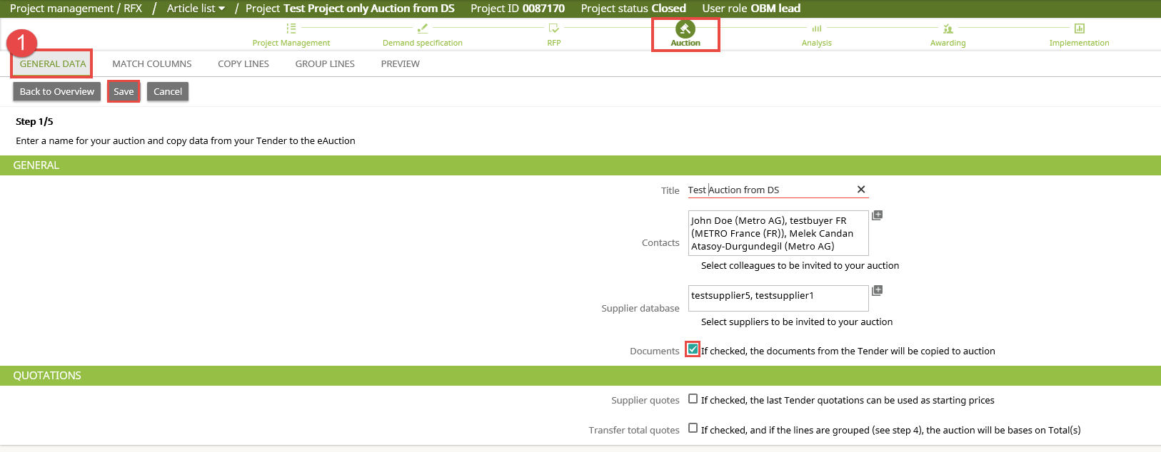

  - Match Columns

In this step, the Auction structure will be matched with the Demand Specification Grid.

- Click on Select grid(s).
- Select the tick box in order to define the grid to be copied to the Auction.
- Click on Apply.

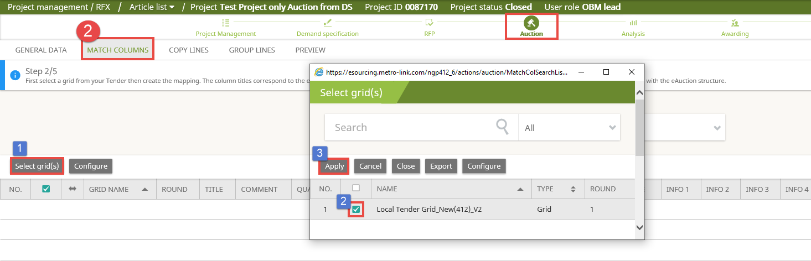

- Click on Edit

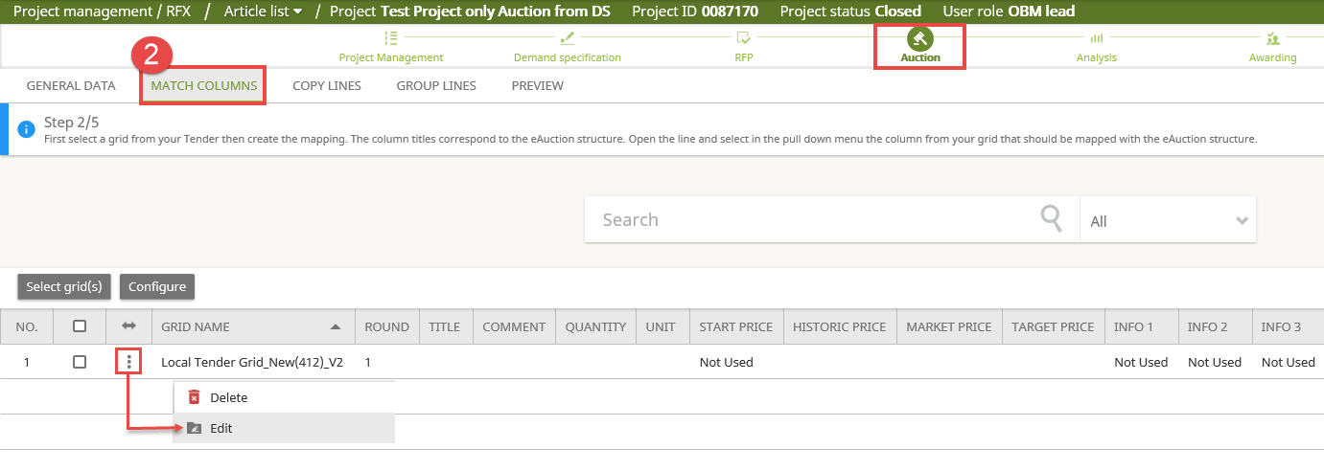

- Match the Demand Specification columns to the Auction structure. Information from each column will be transferred to the auction.
Note: Red highlighted lines are mandatory to be matched.
- Click on Save

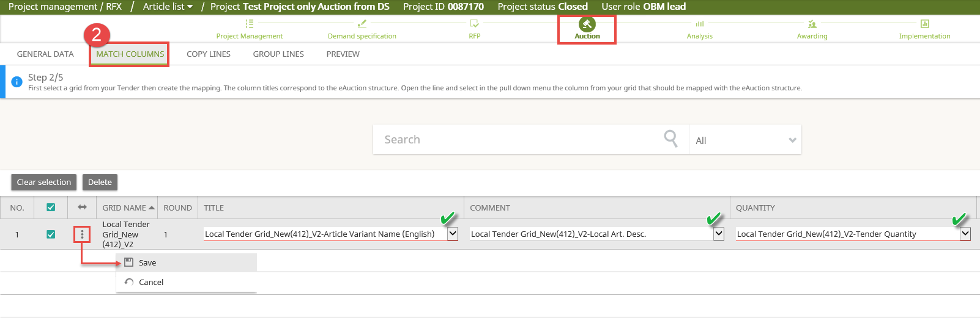

  - Copy Lines
- Make sure that the correct information from Demand Specification is being copied to the related columns.
- Click on Save.

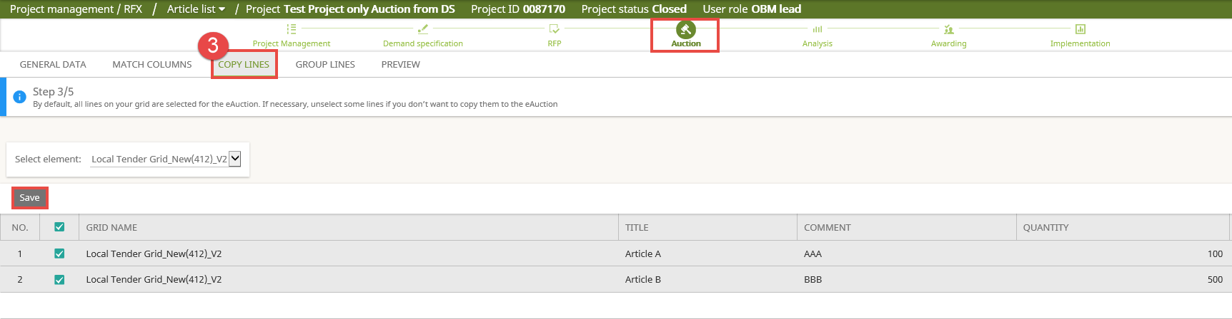

  - Preview
- From this final preview step, you can see all information regarding articles and suppliers from Project Management and Demand Specification.
- If the data is correct, click on Apply to proceed with the Auction Module.

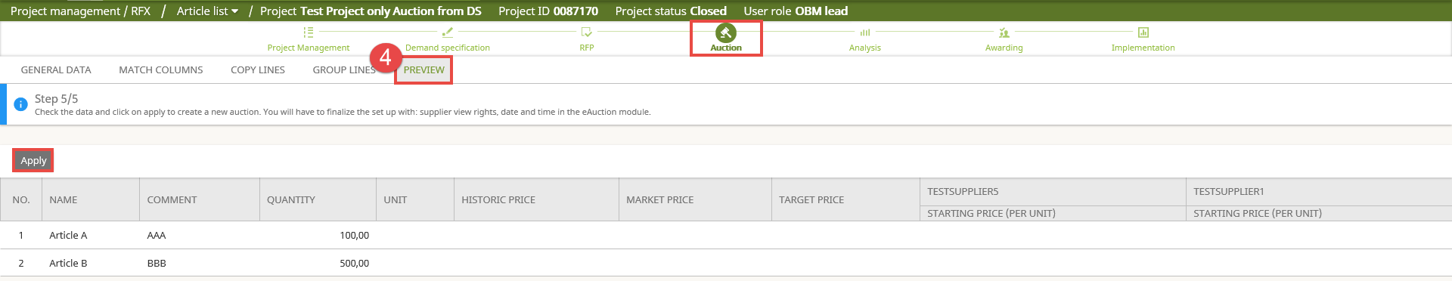

You will be transferred to the Auction Module. From this moment on, you can continue with the details of your Auction such as selecting your Auction Type, Auction Structure, Auction Settings, etc.

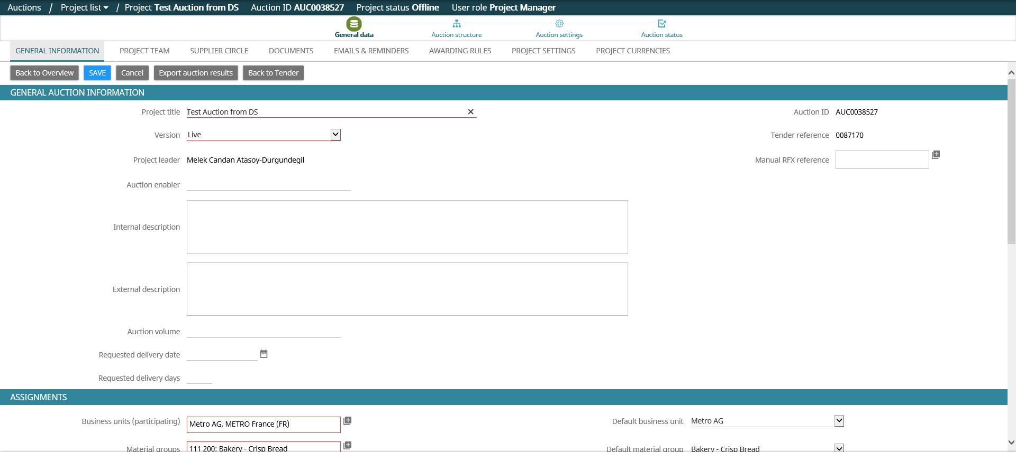

For more information regarding the setting up different types of Auctions, please check the following articles based on your needs:

How to set up English Auction
How to set up Dynamic Auction
How to set up Japanese Auction
How to set up Dutch Auction

After the negotiations are completed and you would like to proceed with finalizing your project by the Awarding step, please also check the following articles:

How to award (local tender) buyer guide
Finalize project (Awarding vs Awarding in process)

If you need further assistance do not hesitate to Contact us.

